# Span:

|  |  |  |  |  |
| --- | --- | --- | --- | --- |
| **Category** | **Single AZ** | **Span Multi-AZ** | **Single Region (Regional)** | **Span Multi-Region** |
| Compute | Placement Groups | Reserved EC2 Instances  ELB (Multi AZs In Single Region) | ELB (Multi AZs In Single Region)  AMIs (However can be copied to other regions) |  |
| IAM |  |  | Security Group | IAM – Roles, Groups, Users, Policy |
| Storage | EBS Replication |  |  | S3 – Global |
| Database | Redshift  Mem-Cache | Postgress  MySQL  Redis | Read-Replica (Can be in another region for MySQL & MariaDB, not for PostgreSQL) |  |
| Networking |  |  | VPC  VPC Peering |  |
| Management |  |  |  |  |
| Application |  | SWF – Manages workflow history across 03 AZs  SNS – Published msgs are redundantly stored across multi-AZs | SQS |  |
|  |  |  |  |  |

# Replication:

RDS: Automated Backups – Enabled By Default

ElastiCache (Redis) - Automated Backups

Redshift - Automated Backups

RDS Database Snapshot – Manual

If Original RDS is deleted

* Automated Backups are deleted
* Manual Snapshot still remain

|  |  |  |
| --- | --- | --- |
| **Synchronous** | **Asynchronous** | **Place** |
|  | EBS Snapshots | EBS Replication in Same AZ. |
| RDS Multi-AZ Replication  (Replicates in same region, but different AZ) | RDS Read Replicas  (Can be in another region for MySQL & MariaDB, not for PostgreSQL) |  |
| Dynamo DB (Automatic, Across three facilities within an AWS region) | Redshift – Maintain 3 Copies in single AZ |  |
|  | AWS Storage Gateway (Uses Internet)  Well you can use AWS Direct Connect |  |

# Port:

* SSH: 22
* RDP: 3389
* HTTP: 80
* HTTPS: 443
* MySQL: 3306
* Redshift: 5439
* MS SQL: 1433

ELB

* Supported Protocols: HTTP/HTTPS/TCP/SSL
* Supported Ports: 25, 80, 443, 1024 – 36635
* TLS – 1.0, 1.1, 1.2
* SSL – 2.0, 3.0

# URLs:

* SQS –
* [https://sqs.us-east-1.amazonaws.com/ <AWS](https://sqs.us-east-1.amazonaws.com/%20%3cAWS) Account ID> /AM_SQS_Queue
* <https://sqs.us-east-1.amazonaws.com/458077907105/AM_SQS_Queue>
* S3
* Bucket URL - http://[s3-us-east-1.amazonaws.com](http://enrollmentbucket.s3-website-us-east-1.amazonaws.com/)/ enrollmentbucket
* Website – http://[enrollmentbucket.s3-website-us-east-1.amazonaws.com](http://enrollmentbucket.s3-website-us-east-1.amazonaws.com/)
* SAML
* AWS sign-in endpoint for SAML is <https://signin.aws.amazon.com/saml>
* IAM users sign-in link:
* https://691680153813.signin.aws.amazon.com/console

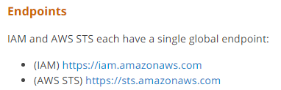

# Tags

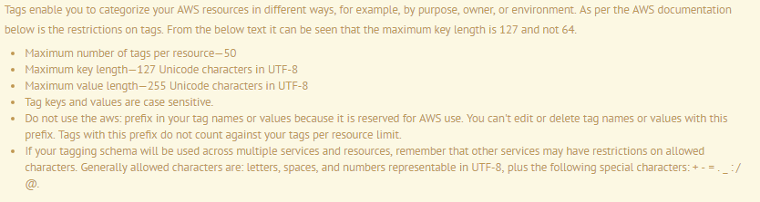

# Compute

## EC2

* Max Number of Tags – 10 Per EC2 Instance
* How many regions are there on the AWS platform currently - 11
* Total Regions Supported for EC2 - 9
* EC2 Instance Limits (Per Region)
* On-Demand : 20
* Reserved: 20
* SPOT – No Limit

|  |  |  |  |  |
| --- | --- | --- | --- | --- |
| Type | Stopped | Detached | Reboot | Terminate |
| Instance Store | No | No | Yes | Deleted |
| EBS Volume | Yes | Yes | Yes | Deleted (By Default).  However can be changed to not delete |

## EBS

* Number of EBS volumes – 5000
* Number of EBS Snapshots – 10,000
* Instance Store Root Volume – 10GB Max
* EBS Store Root Volume – 1Tb to 2Tb

## Auto Scaling

* Default Cooling Period – 5 mins
* Health Check Grace Period – 300Secs (5 Mins) Default

## Elastic Bean Stalk

* Default Limit
* Applications: 75
* Application Version: 1000
* Environments: 200

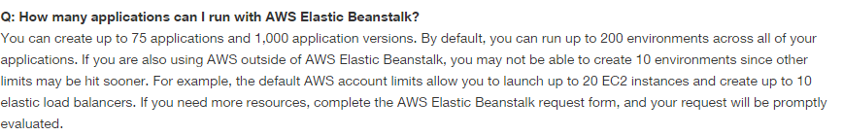

# Storage

## S3

* Per AWS A/c S3 Buckets – 100 (Call AWS to increase limit)
* File Size: 0 Byte – 5 TB
* Object/File Size in Single PUT – 5 GB
* Multipart Upload – Greater than 100 MB

## Glacier

* 1000 Vaults – Per A/c Per Region
* No Max Limit to the total amount of data.
* Individual Archives Limit: 1 Byte – 40 TB
* Object/File Size in Single PUT – 4 GB

## Storage Gateway

* Gateway Stored Volume – 16 TB, 32 Volumes: 512 TB
* Gateway Cached Volume – 32 TB, 32 Volumes: 1 PB
* Virtual Tape – 1 PB (1500 Virtual Tapes) (Takes 24 Hours for retrieval)

## Import/Export

* Max Device Capacity – 16 TB
* Snowball - Max Device Capacity – 50 TB

## CloudFront: (Can be Writable)

* 1000 – Request Per Second
* Max File Size that can be delivered thru CloudFront – 20 GB
* TTL – 24 Hrs (86400 secs)
* Cannot be - RDS, Glacier
* Can be – S3, EC2, ELB, Route53

# Database

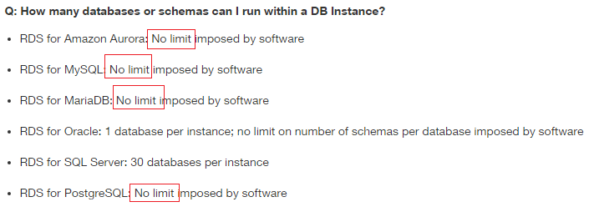

## RDS:

* Limit – 40 RDS Instances (Check above for per RDS instance limits)
* RDS Backup Retention Period – 1 - 35 Days
* Read-Replicas – 05
* MySQL DB Size – 6 TB
* Maximum RDS Volume size using RDS PIOPS storage with MySQL & Oracle DB Engine - 6 TB
* Maximum PIOPS capacity on an MySQL and Oracle RDS instance is 30,000 IOPS (Default)
* Maximum size for a Microsoft SQL Server DB Instance with SQL Server Express edition – 10 GB (SA Mega Quiz #20)

## Dynamo DB

* Storage – No Limit
* Single Item Size (Row Size): 1 – 400 KB
* Local/Global Secondary Index – 05 per Table
* Streams – Stored for 24 Hours only.
* Maximum Write Thruput – Can go beyond 10,000 capacity units, but contact AWS first.
* Projected Non-Key Attributes – 20 Per Table
* LSIs - Limit the total size of all elements (tables and indexes) to 10 GB per partition key value. (GSI does not have any such limitations)
* Tags: 50 Tags Per DynamoDB Table
* Triggers for a Table - Unlimited

## RedShift

* Block Size – 1024 KB
* Maintain 3 copies
* Compute Node: 1 – 128
* Backup Retention Period – 1 Day (Max)

## Aurora

* Maintain 6 copies in 3 AZs

## ElastiCache

* Reserved Cache Nodes – 20

# Networking

## ELB:

* Allowed Load balancer : 20
* Port Supported: HTTP, HTTPS, SSL, TCP
* Acceptable ports for both the HTTPS/SSL and HTTP/TCP connections are 25, 80, 443, and 1024-65535
* Connection Drain – Default 300 Secs, Min – 1 Sec, Max – 3600 Secs (1 Hours)

## Per Region

* 05 - VPCs
* 05 - EIP
* 05 – Virtual Private Gateway
* 50 - VPN Connections
* 50 – Customer Gateway

## Per VPC

* 01 - Internet Gateway
* 01 – IP Address Range
* 200 – Subnets
* 20 - EC2 Instances (Default)

## Per Subnet

* 01 – AZ
* 01 - ACL

## Notes:

* An instance retains its Private IP and persist across starts and stops
* Assign multiple IP addresses to your instances
* EIP is associated with your AWS account and not a particular instance. It remains associated with your account until you explicitly release it.
* Subnet Cannot Span Multi-AZ
* Security Group Can Span Multi-AZ
* N/W ACL Can Span Multi-AZ
* Route Table Can Span Multi-AZ

## VPC CIDR Block

* When you create a VPC, we recommend that you specify a CIDR block from the private (non-publicly routable) IPv4 address ranges as specified in [RFC 1918](http://www.faqs.org/rfcs/rfc1918.html):
* 10.0.0.0 - 10.255.255.255 (10/8 prefix)
* 172.16.0.0 - 172.31.255.255 (172.16/12 prefix)
* 192.168.0.0 - 192.168.255.255 (192.168/16 prefix)

## Route53

* Number of domains you can manage using Route 53 is 50 (however it is a soft limit and can be raised by contacting AWS support)

# Management

## Cloud Watch

* Logs – Unlimited/ Indefinitely
* Alarms – 2 Weeks (14 Days)
* Metrics – 2 Weeks (14 Days)
* For more than 2 weeks, use API – GetMetricStatistics or some third party tools
* EC2 Metrics Monitoring
* Standard – 5 Mins
* SNS – Always sends in 5 mins. Cannot be configured for 1 min
* EMR - Always sends in 5 mins. Cannot be configured for 1 min
* Detailed – 1 Min (Paid)
* Custom Metrics Monitoring – Minimum 1 Min

## Cloud Formation

* Templates – No Limits
* Stack – 200 Per A/c
* Parameters – 60 per Template
* Output – 60 per Template
* Description Field Size – 4096 Characters

## Cloud Trail

* 5 Trails – Per Region
* Deliver Log Files – Every 5 mins
* Capture API Activity – Last 7 Days

## OpsWorks

* 40 Stacks
* 40 Layers per stack
* 40 Instances per stack
* 40 - Apps per stack

# Security

* Users: 5000 per account
* Groups: 100 per Account
* Roles: 250 Per AWS Account
* User can be part of – 10 Groups (Max)
* KMS
* Master Keys – 1000 Per AWS A/c
* Data Key – No Limit
* Resource Base Permission:
* S3, Glacier, EBS
* SNS, SQS
* Elastic Bean Stalk, Cloud Trail

# Analytics

EMR:

* EC2 Instances Across All clusters - 20

# Application

## SQS:

* Visibility Timeout – 30 Secs (Default) (Otherwise 12 hours) Value must be between 0 seconds and 12 hours.
* Retention Period – 4 days (Default). Can be set form 1 min to 2 Weeks (14 Days) Value must be between 1 minute and 14 days.
* Delivery Delay – 0 Secs (Default). Can be set form 0 Secs to 15 Mins
* Receive Message Wait Time (Max Long Polling Timeout) – 20 Secs Value must be between 0 and 20 seconds.
* Message Size – 256 KB Value must be between 1 and 256 KB.
* Number of Queues – Unlimited
* Number of messages per queue – Unlimited
* Queue name: 80 characters

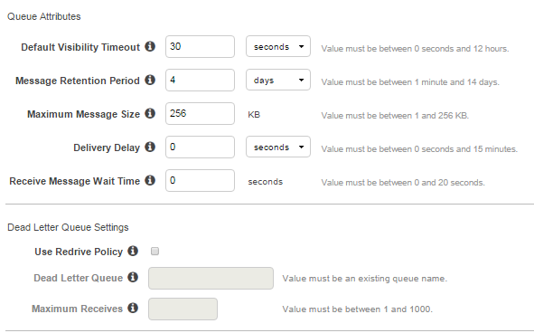

|  |  |
| --- | --- |
| **Default Visibility Timeout** | The length of time (in seconds) that a message received from a queue will be invisible to other receiving components. |
| **Message Retention Period** | The amount of time that Amazon SQS will retain a message if it does not get deleted. |
| **Maximum Message Size** | Maximum message size (in bytes) accepted by Amazon SQS. |
| **Delivery Delay** | The amount of time to delay the first delivery of all messages added to this queue. |
| **Receive Message Wait Time** | The maximum amount of time that a long polling receive call will wait for a message to become available before returning an empty response. |
| **Use Redrive Policy** | Send messages into a dead letter queue after exceeding the Maximum Receives. |
| **Dead Letter Queue** | The name of the existing queue that will serve as the dead letter queue. |
| **Maximum Receives** | The maximum number of times a message can be received before it is sent to the Dead Letter Queue. |

## SES:

* SES Email Size – 10 MB (including Attachments)
* SES Recipients – 50 for every message
* Sending Limits:

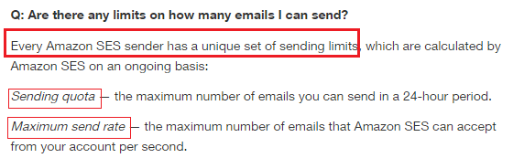

## SNS:

* Topic – 1,00,000 Lakh (Per A/c)
* Subscription – 10 Million Per Topic (Per A/c)
* TTL – 04 Weeks
* Topic Name: 256 Character

## SWF:

* Retention Period – 1 Year
* Max workflow execution – 1 Year
* History of Execution – 90 Days Max
* Max  Workflow and Activity Types – 10,000
* Max Amazon SWF domains – 100
* Max open executions in a domain – 1,00,000

## Elastic Encoder

* Jobs – 10k Per Pipeline